Document title (Segoe UI, 24 pt.)

Heading 1 (Segoe UI, 20 pt.)

Heading 2 (Calibri, 16 pt., Bold)

Heading 3 (Calibri, 14 pt., Bold)

Heading 4 (Calibri, 12 pt., Bold)
Body text (Calibri, 11 pt., 1.15 line spacing)
Hyperlinks (Hyperlink, blue, underlined text)
Note: Use the Styles gallery in this template to apply pre-established font treatments.

Tables
This template contains a built-in table style. Insert a table with the desired number of rows and columns, then add your data. Consider using multiple tables to break down complex information.
Table 1. Descriptive name
Column 1 | Column 2 | Column 3 | Column 4 | Column 5

Photos and graphics
Find approved photos in the WDFW Media Library. Seek assistance from your communications manager if you need help locating an image.

Formatting tips
- Photo credits are required for all photos. Add captions for context. Use Photo caption style.
- Add alt text describing the photo or graphic. Right click > view alt text > edit.
- Format photos In Line with Text. Click photo > picture format menu > wrap text > In Line with Text. Left justify photos.
- Adjust spacing below photos. Click photo > select Photo spacing style.
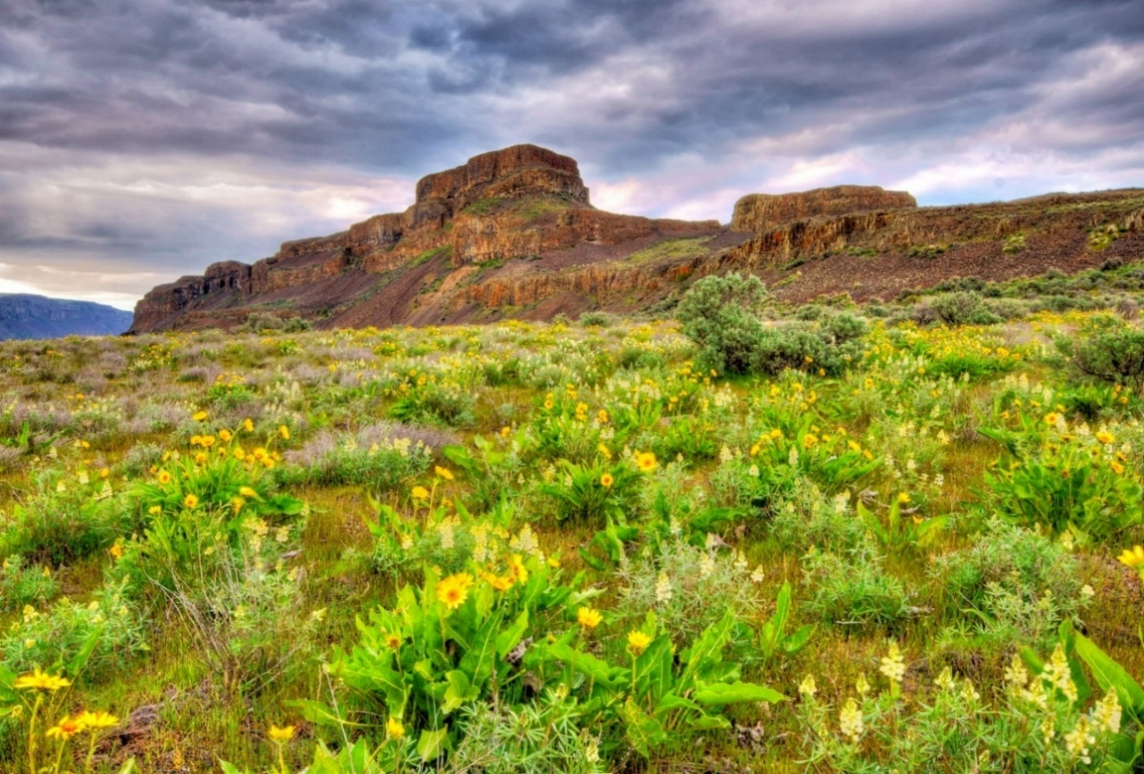
Photo caption. Photo by NAME.

